Transforming Industrial Operations through Industry 4.0’s Integration of Emerging Solutions

|  |  |  |
| --- | --- | --- |
| 1st Sonali Mali  *B.Tech CSE (AIML)*  *D. Y. Patil College Of Engineering & Technology*  Kolhapur, India  sonalibhanudasmali101@gmail.com | 2nd Shravani Kulkarni  *B.Tech CSE (AIML)*  *D. Y. Patil College Of Engineering & Technology*  Kolhapur, India  shrau.k.7@gmail.com | 3rd Tanvi Patil  *Asst. Prof., Dept. of CSE (AIML)*  *D. Y. Patil College Of Engineering & Technology*  Kolhapur, India  drpatiltanvi27@gmail.com |
| 4th Siddheshwar Patil  *Asso. Prof., Dept. of CSE (AIML)*  *D. Y. Patil College Of Engineering & Technology*  Kolhapur, India  siddheshwar.patil@gmail.com | 5th Shamal Desai  *Asst. Prof., Dept. of CSE (AIML)*  *D. Y. Patil College Of Engineering & Technology*  Kolhapur, India  shamaldesai.dypcet@gmail.com | 6th Rahul Patil  *Govt Industrial Training Institute, Phondaghat*  Sindhudurg, India  [rahulpatil06@gmail.com](mailto:pravindesaikarad@gmail.com) |

***Abstract***— **The Industry 4.0 revolution seeks to transform manufacturing and industrial operations through advanced technologies, including the Internet of Things (IoT), Industrial Internet of Things (IIoT), Cloud Computing, Big Data Analytics, Blockchain, Augmented Reality (AR), Virtual Reality (VR), 3D Printing, Artificial Intelligence (AI), Machine Learning (ML), Deep Learning (DL), Robotics, Computer Vision (CV), Natural Language Processing (NLP), and 5G Technology. This convergence of technologies is giving birth to smart factories that allow real-time data exchange and autonomous decision-making. Eventually, such changes will enable organizations to gain considerable productivity growth, enhanced flexibility, and responsiveness to market demands. This paper outlines how such technologies are changing the production processes through increased transparency and automation throughout the supply chains of various industrial sectors. It also pays attention to the socio-economic changes that digital transformation has on workers and gives a sense of how industries handle complicated issues while trying to remain competitive and sustainable in an ever-changing economic environment.**

***Index Terms***— **Industry 4.0, IoT, Smart** **Factories,** **Automation, Big Data Analytics, Artificial Intelligence, Sustainability**

# Introduction

Industry 4.0, or the Fourth Industrial Revolution, is revolutionizing the global industrial landscape by integrating advanced digital technologies with traditional manufacturing processes, resulting in increased automation, connectivity, and intelligent decision-making [1,2]. Key technologies driving this transformation include the Internet of Things (IoT), Industrial Internet of Things (IIoT), Cloud Computing, Big Data Analytics, Blockchain, Augmented Reality (AR), Virtual Reality (VR), Artificial Intelligence (AI), Machine Learning (ML), Deep Learning (DL), Robotics, Cybersecurity, Natural Language Processing (NLP), and 5G Networks [3,4,5]. These technologies empower smart factories with real-time data exchange, process optimization, and predictive maintenance capabilities, leading to improved operational efficiency, product quality, and minimized downtime [6,7,8]. 5G has significantly advanced Industry 4.0 by enabling high-speed, low-latency communication, essential for seamless real-time data exchanges and machine interactions in sectors like autonomous robotics and smart warehousing [12,13].

Blockchain enhances security by ensuring data integrity and traceability during production and distribution [14,15]. Meanwhile, AR and VR have transformed training, remote maintenance, and product design into immersive experiences, improving efficiency and outcomes [16]. However, the widespread adoption of Industry 4.0 comes with challenges, including increased cybersecurity risks, the need to reskill workers, and addressing data privacy and ethical concerns [17-20].

The main objective of this paper is to explore how Industry 4.0 technologies are reshaping manufacturing systems, focusing on their impact on operational efficiency, sustainability, and adaptability. It examines the practical applications and case studies of IoT, Cloud Computing, AI, Big Data Analytics, Blockchain, and 5G, providing insights on navigating digital transformation. The paper also explores the shift toward Industry 5.0, emphasizing the evolution of human-centric and sustainable industrial practices [19].

# Background

The history of information technology reveals great strides toward the establishment of Industry 4.0. During the 1960s, the advent of mainframes brought a gargantuan stride in computing capacity and processing data. Large central computers were used mainly by governmental organizations and some industries for scientific and industrial applications and created computing as part and parcel of organizational activities and made calculations and data management previously unattainable [1].

Industry 4.0 emerged as a new paradigm, where cyber-physical systems, real-time data analytics, and interconnected devices created smarter, more efficient, and flexible manufacturing systems. These advancements have revolutionized production lines, making them more adaptable, sustainable, and capable of responding to consumer demands in real time. Industry 4.0 continues to evolve, driving the digital transformation of industries and shaping the future of global manufacturing.

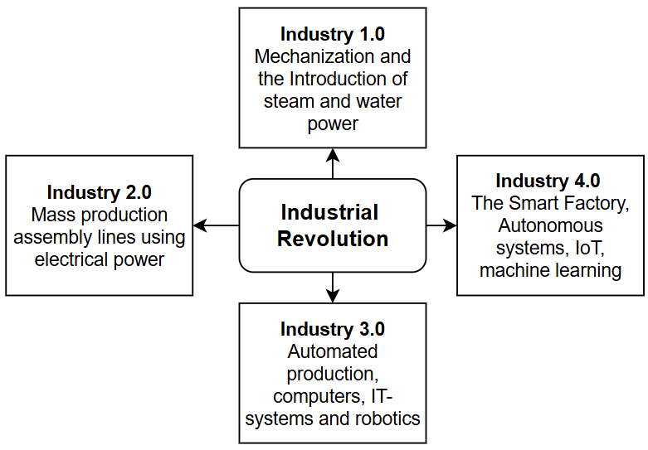

**Fig 1:** Industrial Revolution

The development of industrial systems has passed through a series of key leaps, characterized by tremendous advancements in technology, which transformed production and the manufacturing process. Industry 1.0 was the first industrial revolution (fig 1), where the mechanization of production with the introduction of steam and water power began. There was also the development of mechanized textile mills and steam engines, marking the beginning of mass production [1]. Following Industry 2.0 were the phases with the use of electrical power and mass production assembly lines, which were well spread by Henry Ford. It resulted in increased efficiency and scalability in production [2]. The third Industrial Revolution, Industry 3.0, came with automation, computers, and information systems, where robotic equipment played a pivotal role in transforming production operations into more streamlined processes. With this, digitalized production environments emerged [3]. Finally, came Industry 4.0 that elaborated on intelligent factories, self-governing systems, and IoT along with ML that connects sophisticated technologies in real-time, enabling the exchange of data, predictiveness, and autonomous decision-making capabilities with amplified efficiency and flexibility in manufacturing [4]. This overview recites key technological milestones that have shaped the journey toward Industry 4.0 with an illustration of how each industrial revolution has contributed to current advancements in technology and industry practices.

# Literature Review

The following literature review looks at the effects of Industry 4.0 technologies on manufacturing and industrial processes. Khayyam et al. (2020) emphasize the development of advanced calculation models and data models for improved decision-making in manufacturing. They suggest that such models will drive the future of manufacturing systems in terms of efficiency and productivity [1].

Alladi et al. (2019) explore how Blockchain can be integrated into IoT systems to improve the reliability and accountability of Industry 4.0. Their research shows how IoT and blockchain can support secure, real-time data management in manufacturing environments [2]. Verma et al. (2022) highlights the role of blockchain as a key enabler in Industry 5.0, focusing on its ability to enhance secure data sharing between various stakeholders. They argue that blockchain is crucial for the future digital transformation of industries [3]. Weiss et al. (2021) introduces the concept of human-robot collaboration (HRC), identifying it as a necessary step in unlocking the potential of human-robot partnerships in Industry 5.0. They advocate for further research into optimizing HRC systems for industrial applications [4]. Supriya et al. (2024) discuss the necessity of new teaching methodologies for preparing professionals in the field of Industry 5.0. Their study focuses on how educational systems must adapt to industry demands driven by digital transformation and technological advancements [5]. Mishra et al. (2022) explore the impact of intelligent computing in the electrical utility sector, showing how AI and machine learning can optimize service delivery. They emphasize the role of these technologies in improving efficiency and reliability in energy management [6].

Tay et al. (2018) define the core components of Industry 4.0 and emphasize the importance of governmental support in fostering technological adoption. They outline the key subsystems that constitute Industry 4.0, such as automation and IoT integration [7]. Rojko (2017) investigates the role of digitalization in improving manufacturing performance. Rojko presents foundational knowledge on the technological changes that have shaped modern industries, particularly focusing on automation and data exchange [8]. Abdullah et al. (2022) examine the relationship between the adoption of Industry 4.0 technologies and manufacturing decision-making. Their research points out the need for further studies to identify the right circumstances and strategies for implementing these technologies [9]. Fraga-Lamas et al. (2021) explore how next-generation auto-identification and traceability technologies can support shipbuilding industries. Their research focuses on Industry 5.0's role in improving transparency and efficiency through innovative tracking systems [10].

Pilevari (2020) tracks the milestones from Industry 1.0 to 5.0, analyzing the technological advancements and shifts in manufacturing practices. They highlights key moments of transformation that have enabled smarter, more flexible production systems [11]. Asadollahi-Yazdi et al. (2020) investigate whether Industry 4.0 represents a revolution or an evolution in manufacturing practices. Their findings emphasize that while technological changes are revolutionary, they occur within the context of continuous industrial development [12]. Nayyar and Kumar (2020) suggest a roadmap for adopting Industry 4.0 technologies, emphasizing smart production, business management, and sustainable development. They discuss how organizations can transition toward these advanced technologies to enhance operational efficiency [13]. Rudiyanto et al. (2020) research focuses on the intersection of technology and social transformation across industrial revolutions. They analyze how each industrial revolution has influenced societal structures and organizational development [14]. Dalenogare et al. (2018) propose a framework for optimizing manufacturing efficiency using Industry 4.0 technologies. Their study highlights how these technologies can be used to automate and streamline production processes, improving overall productivity [15].

Frank et al. (2019): This study examines the adoption of Industry 4.0 technologies across manufacturing organizations. It highlights how companies are utilizing these technologies to enhance production efficiency and decision-making processes [16]. Zheng et al. (2021) focus on the integration of Industry 4.0 technologies in manufacturing. They present emerging trends in the field, identifying key technologies and their potential applications in modern industrial settings [17]. Laskurain-Iturbe et al. (2021) discuss how digital technology can support the circular economy in manufacturing. The authors argue that Industry 5.0 plays a crucial role in integrating sustainability and circularity into industrial production processes [18]. Wadhwani (2024) focuses on how advancements in IoT and robotics are driving the shift from Industry 4.0 to Industry 5.0. They emphasized how this transition fosters more human-centric, creative, and sustainable production systems [19]. Leng et al. (2022) study on Industry 5.0 highlights its focus on human-centric value creation, sustainability, and social responsibility. They argue that the future of industry will depend on balancing technological advancement with societal well-being [20].

Huang et al. (2022) investigate how Industry 5.0 promotes a co-evolutionary model between humans and machines. It emphasizes the importance of aligning technological progress with societal and ecological values for a sustainable future [21]. Akundi et al. (2022) discuss how Industry 5.0 reshapes the human-machine relationship to promote creativity, sustainability, and ethical practices. Their research suggests that collaborative innovation between humans and machines will define the future of industry [22]. Maddikunta et al. (2022): This study highlights the crucial role of AI in Industry 5.0 by enhancing human creativity and fostering responsible industrial practices. The authors emphasize that AI will be key to achieving both technological and societal goals in the coming years [23]. Pilevari (2020) revisits the evolution from Industry 1.0 to Industry 5.0, emphasizing human-centric processes and sustainable practices. Their study proposes that future industrial systems should prioritize ethical, environmentally friendly production methods [24]. Sarkar et al. (2024) discuss how Industry 5.0 integrates digital, green, and social transitions to promote sustainable and ethical growth. Their research advocates for the alignment of technological innovations with broader societal and environmental objectives [25].

Verma (2024) explores how Industry 5.0 enhances the human experience by integrating technological optimization with societal and ecological considerations. The author suggests that this balance will drive long-term sustainable growth in the industrial sector [26]. Schröder et al. (2024): Schröder and colleagues discuss how Industry 5.0 integrates digital, green, and social transitions to foster inclusive growth. Their work focuses on the ethical and ecological aspects of industrial transformation, which should shape future manufacturing practices [27]. Enang et al. (2023) explore the shift in Industry 5.0 toward value-centric approaches, emphasizing human creativity and sustainability. The authors highlight the importance of aligning technological advancements with societal needs and environmental concerns [28]. Zizic et al. (2022) discuss how Industry 5.0 represents a shift toward human-machine collaboration, with a focus on ethical practices and environmental sustainability. Their study advocates for industrial systems that prioritize these values in their design and implementation [29]. Leng et al. (2022) investigate the relationship between human-machine collaboration and societal goals in Industry 5.0. They emphasize the importance of ethical considerations and environmental sustainability in shaping future industrial ecosystems. Schröder et al. (2024) conclude that Industry 5.0 represents a profound shift in manufacturing practices. Their research underscores the need for a human-centric approach to manufacturing that integrates ethical, technological, and environmental considerations for inclusive growth [30].

# Key Technologies In Industry 4.0

The critical technologies driving Industry 4.0 include the Internet of Things, cloud computing, big data analytics, and artificial intelligence. Through these technologies, organizations can connect directly and gain access to information easily, hence their relevance to optimizing operations and improving decision-making. In general, these technologies enhance efficiency, adaptability, and responsiveness in industries and position them for better performance in a highly competitive world [5].

The following are critical technologies driving the transformation of Industry 4.0

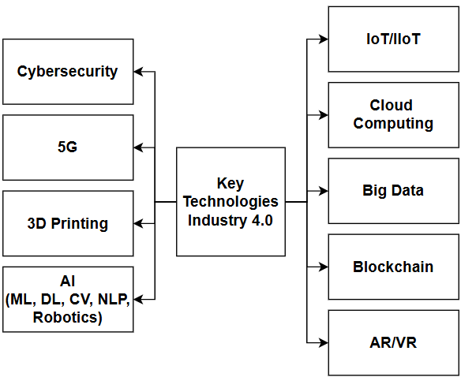

**Fig 2:** Key Technologies in Industry 4.0

Industry 4.0 (Fig 2) utilizes transformative technologies to drive manufacturing innovation. IoT and IIoT make the use of connected devices and automation [1]. Cloud computing helps in scalable data storage, collaboration, and insight into operations [9]. Big data analytics helps develop predictive insights for better decision-making [10]. Blockchain ensures secure transactions in a transparent manner for supply chains [2]. Augmented and virtual reality enhance training, design, and maintenance with more precision [7]. Cybersecurity solutions help safeguard data integrity and operations [8]. 5G technology enhances network speed and real-time connectivity [11]. Additive manufacturing supports customization and sustainability [5]. AI and machine learning automate decision-making, while deep learning aids defect detection [15, 19, 3]. Robotics improve precision and productivity, and computer vision ensures product quality [1]. NLP enhances customer service and communication workflows [7]. These technologies optimize operations, foster innovation, and boost competitiveness.

# Potential Use Cases And Applications

Industry 4.0 technologies such as the Internet of Things, big data analytics, and automation transform the manufacturing processes and improve operations efficiency. These innovations benefit businesses through the streamlining of processes, quality enhancement of products, and swift adaptation to market demands.

Below is the table presenting various use cases in Industry 4.0 (Table 1), illustrating the application of advanced technologies to enhance operational efficiency, automation, and innovation across different sectors.

|  |  |  |  |
| --- | --- | --- | --- |
| **Sr. No.** | **Technology** | **Applications** | **Real-World Use Cases** |
| 1 | IoT and IIoT | Asset tracking, Predictive maintenance, Remote monitoring, Data sharing, Remote collaboration, AI-driven insights | Magna Steyr: Automated stock replenishment, John Deere: Self-driving tractors, Hitachi: Real-time data analysis |
| 2 | Cloud Computing | Demand forecasting, Asset tracking, Secure transactions, Training | Tesla: Data gathering for self-driving technology, Siemens: Predictive analytics for manufacturing |
| 3 | Big Data and Analytics | Maintenance, Product design, Threat detection, Data protection, Operational continuity | IBM Food Trust: Food product tracing, Maersk: Blockchain-based cargo tracking with Trade Lens |
| 4 | Blockchain | Smart factories, Autonomous vehicles | Boeing: AR glasses for technician guidance, Volkswagen: VR training for assembly techniques |
| 5 | AR/VR | Training, Maintenance, Product design | Siemens: Multi-layered cybersecurity strategy, Cisco: Industrial cybersecurity solutions |
| 6 | Cybersecurity | Threat detection, Data protection, Operational continuity | Ericsson: 5G solutions for manufacturing, Nokia: Seamless communication in factories |
| 7 | 5G Technology | Smart factories, Autonomous vehicles | GE: Lightweight aircraft components, Adidas: Customized shoe soles for athletes |
| 8 | 3D Printing | Prototyping | Google: Energy optimization in data centers, BMW: Maintenance prediction in manufacturing |
| 9 | Artificial Intelligence | Predictive maintenance, Quality control, Process optimization | Google: Energy usage optimization, Predictive analytics |
| 10 | Machine Learning | Predictive maintenance, Process optimization | Google: Energy usage optimization, Predictive analytics |
| 11 | Deep Learning | Quality control, Autonomous navigation | Assembly, Material handling |
| 12 | Robotics | Quality inspection, Process optimization | Amazon: Robotics in fulfillment centers, Canon: Defect detection in cameras |
| 13 | Computer Vision | Quality inspection | Alibaba: Product recommendations, Fanuc: Robots for welding and assembly |
| 14 | Natural Language Processing | Customer support, Documentation management | BMW: Equipment failure prediction, Tesla: Autonomous driving |

**Table 1:** Use Cases in Industry 4.0

# Impact and Sustainability

The integration of impact and sustainability in Industry 4.0 is representative of the great transformative potential of advanced technologies in driving operational efficiency while solving environmental and social challenges. Smart manufacturing and automation enhance productivity and economic growth by keeping track of machine performance and providing predictive maintenance and automated workflows to prevent downtime and help optimize the production processes with faster cycles and improved quality control [10].

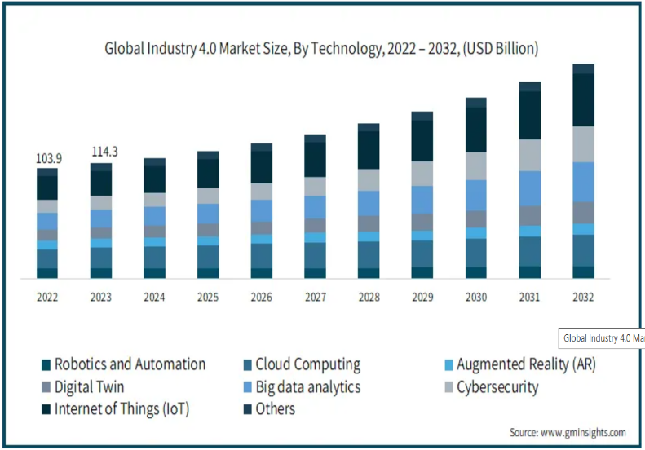

Fig 3: Industry 4.0 Market Size by Technology

The Global Market Insights Inc. Industry 4.0 Market Size - By Technology report, authored by Preeti Wadhwani and published in July 2024 The Industry 4.0 market, valued at USD 114.3 billion in 2023, is expected to grow at a CAGR of 20.2%, reaching USD 555.1 billion by 2032, driven by the adoption of digital technologies, investments in IoT and cloud computing, and automation in manufacturing [21]. Automation improves operational efficiency and reduces production costs by minimizing errors while enabling real-time decision-making and predictive maintenance. Challenges like data security must be addressed for sustainable growth. Innovations like additive manufacturing (3D printing) are gaining momentum, offering cost-effective, on-demand production and reducing waste [21].

# Vision For Industry 5.0

Industry 5.0 focuses on human-centered, sustainable, and resilient principles, emphasizing creativity, societal values, and environmental responsibility. It draws on global initiatives like Japan's Society 5.0 [12], promoting inclusiveness, adaptability, and social equity while aligning economic growth with social and environmental well-being [13].

Key frameworks for Industry 5.0 include human-machine interaction, bio-inspired technologies, digital twins, AI, and energy-efficient technologies [12]. These frameworks aim to create a seamless collaboration between human workers and machines, enhancing productivity while prioritizing well-being and sustainability. Auto-ID technologies further enhance traceability and transparency within supply chains, ensuring efficient tracking and monitoring of goods. AI plays a critical role in optimizing operations by predicting and preventing inefficiencies, while also improving decision-making processes at all levels [22, 23, 24]. Big Data, cloud computing, and 5G/6G technologies enable faster data transfer, real-time analytics, and improved connectivity, making decision-making more agile and informed [13, 27]. Digital twins allow for real-time monitoring and optimization of manufacturing processes. The integration of these technologies ensures that Industry 5.0 is not just about efficiency but also about a more inclusive, human-centered, and responsible approach to industrial development.

Below is the table outlining the transition from Industry 4.0 to Industry 5.0, highlighting the key technological advancements and their resulting impacts (Table 2).

|  |  |  |  |
| --- | --- | --- | --- |
| **Sr No.** | **Industry 4.0 Fact** | **Key Transition (Technologies)** | **Industry 5.0 Fact** |
| 1 | Industry 4.0 focuses on automation, AI, IoT, and big data. | Transition to human-centric systems with AI, robotics, and IoT. | Industry 5.0 emphasizes human-machine collaboration and sustainability with AI, IoT, and robotics [22]. |
| 2 | Industry 4.0 enhances manufacturing efficiency with AI and robotics. | Move towards incorporating societal values with digital technologies. | Industry 5.0 integrates sustainability, social equity, and human creativity alongside digital technologies [23,29]. |
| 3 | Industry 4.0 focuses on automation for predictive maintenance. | Transition to eco-friendly, human-centered technologies. | Industry 5.0 highlights sustainability, worker empowerment, and circular economy practices [24]. |
| 4 | Industry 4.0 relies on data-driven automation and cloud computing. | Shift towards value-driven, human-focused technologies. | Industry 5.0 combines AI, robotics, and IoT with a focus on sustainability and social responsibility [25-32]. |
| 5 | Industry 4.0 drives digital transformation in manufacturing. | Shift to renewable energy, 3D printing, and sustainable practices. | Industry 5.0 emphasizes human involvement and eco-friendly, socially responsible technology integration [26]. |
| 6 | Industry 4.0 optimizes operations using AI and IoT. | Transition to human-centric, socially equitable systems. | Industry 5.0 fosters human-technology collaboration for societal and environmental benefits [27]. |
| 7 | Industry 4.0 uses IoT and automation for efficiency. | Transition to ethical and inclusive technological systems. | Industry 5.0 integrates technology with human creativity and a focus on sustainability and inclusivity[28]. |

**Table 2:** Transition from Industry 4.0 to Industry 5.0 and its Impacts

# Conclusion And Future Scope

Industry 4.0 has revolutionized manufacturing by integrating IoT, big data analytics, and automation, improving efficiency and optimizing supply chains. The shift to Industry 5.0 focuses on human-machine collaboration and sustainability, aligning industrial practices with social and environmental goals. Inspired by Industry 4.0, Industry 5.0 aims to create adaptive, sustainable systems that enhance work quality and resilience, driving more equitable and sustainable industrial growth.

# References

1. Khayyam, Hamid, Ali Jamali, Alireza Bab-Hadiashar, Thomas Esch, Seeram Ramakrishna, Mahdi Jalili, and Minoo Naebe. "A novel hybrid machine learning algorithm for limited and big data modeling with application in industry 4.0." IEEE Access 8 (2020): 111381-111393.
2. Alladi, Tejasvi, Vinay Chamola, Reza M. Parizi, and Kim-Kwang Raymond Choo. "Blockchain applications for industry 4.0 and industrial IoT: A review." IEEE Access 7 (2019): 176935-176951.I. S. Jacobs and C. P. Bean, “Fine particles, thin films, and exchange anisotropy,” in Magnetism, vol. III, G. T. Rado and H. Suhl, Eds. New York: Academic, 1963, pp. 271–350.
3. Verma, Ashwin, Pronaya Bhattacharya, Nirav Madhani, Chandan Trivedi, Bharat Bhushan, Sudeep Tanwar, Gulshan Sharma, Pitshou N. Bokoro, and Ravi Sharma. "Blockchain for industry 5.0: Vision, opportunities, key enablers, and future directions." IEEE Access 10 (2022): 69160-69199.
4. Weiss, Astrid, Ann-Kathrin Wortmeier, and Bettina Kubicek. "Cobots in industry 4.0: A roadmap for future practice studies on human–robot collaboration." IEEE Transactions on Human-Machine Systems 51, no. 4 (2021): 335-345.
5. Talebkhah, Marieh, Aduwati Sali, Meisam Gordan, Shaiful Jahari Hashim, and Fakhrul Zaman Rokhani. "Comprehensive review on development of smart cities using industry 4.0 technologies." IEEE Access (2023).
6. Sajjad, Ahmad, Wasim Ahmad, Salman Hussain, and Raja Majid Mehmood. "Development of innovative operational flexibility measurement model for smart systems in industry 4.0 paradigm." IEEE Access 10 (2021): 6760-6774.
7. Supriya, Y., Dasari Bhulakshmi, Sweta Bhattacharya, Thippa Reddy Gadekallu, Pratik Vyas, Rajesh Kaluri, S. Sumathy, Srinivas Koppu, David J. Brown, and Mufti Mahmud. "Industry 5.0 in Smart Education: Concepts, Applications, Challenges, Opportunities, and Future Directions." IEEE Access (2024).
8. Mishra, Manohar, Monalisa Biswal, Ramesh C. Bansal, Janmenjoy Nayak, Ajith Abraham, and Om P. Malik. "Intelligent computing in electrical utility Industry 4.0: Concept, key technologies, applications and future directions." IEEE Access 10 (2022): 100312-100336.
9. Tay, Shu Ing, Te Chuan Lee, N. Z. A. Hamid, and Ahmad Nur Aizat Ahmad. "An overview of industry 4.0: Definition, components, and government initiatives." Journal of Advanced Research in Dynamical and Control Systems 10, no. 14 (2018): 1379-1387.
10. Rojko, Andreja. "Industry 4.0 concept: Background and overview." International Journal of Interactive Mobile Technologies 11, no. 5 (2017).
11. Abdullah, Fawaz M., Mustafa Saleh, Abdulrahman M. Al-Ahmari, and Saqib Anwar. "The impact of Industry 4.0 technologies on manufacturing strategies: proposition of technology-integrated selection." *Ieee Access* 10 (2022): 21574-21583.
12. Fraga-Lamas, Paula, José Varela-Barbeito, and Tiago M. Fernández-Caramés. "Next generation auto-identification and traceability technologies for industry 5.0: A methodology and practical use case for the shipbuilding industry." *Ieee Access* 9 (2021): 140700-140730.
13. Pilevari, Nazanin. "Industry revolutions development from Industry 1.0 to Industry 5.0 in manufacturing." *Journal of Industrial Strategic Management* 5, no. 2 (2020): 44.
14. Asadollahi-Yazdi, Elnaz, Paulin Couzon, Nhan Quy Nguyen, Yassine Ouazene, and Farouk Yalaoui. "Industry 4.0: Revolution or evolution?." *American Journal of Operations Research* 10, no. 06 (2020): 241.
15. Nayyar, Anand, and Akshi Kumar, eds. *A roadmap to industry 4.0: Smart production, sharp business and sustainable development*. Berlin: Springer, 2020.
16. Rudiyanto, Fred Soritua, Agus Sachari, Setiawan Sabana, and Yannes Martinus Pasaribu. "The Role of Technology and social transformation challenge in Industrial Revolution 1.0–4.0." *FoITIC* (2020): 214-227.
17. Dalenogare, Lucas Santos, Guilherme Brittes Benitez, Néstor Fabián Ayala, and Alejandro Germán Frank. "The expected contribution of Industry 4.0 technologies for industrial performance." *International Journal of production economics* 204 (2018): 383-394.
18. Frank, Alejandro Germán, Lucas Santos Dalenogare, and Néstor Fabián Ayala. "Industry 4.0 technologies: Implementation patterns in manufacturing companies." *International journal of production economics* 210 (2019): 15-26.
19. Zheng, Ting, Marco Ardolino, Andrea Bacchetti, and Marco Perona. "The applications of Industry 4.0 technologies in manufacturing context: a systematic literature review." *International Journal of Production Research* 59, no. 6 (2021): 1922-1954.
20. Laskurain-Iturbe, Iker, Germán Arana-Landín, Beñat Landeta-Manzano, and Naiara Uriarte-Gallastegi. "Exploring the influence of industry 4.0 technologies on the circular economy." Journal of Cleaner Production 321 (2021): 128944.
21. Wadhwani, Preeti. *Industry 4.0 Market Size - By Technology (IoT, Digital Twin, Big Data Analytics, Cybersecurity, Cloud Computing, Robotics & Automation, Augmented Reality), By End-user (Manufacturing, Automotive, Healthcare, Energy & Utilities, Food & Beverage), Forecast 2024 - 2032*. Global Market Insights Inc., July 2024.
22. Leng, Jiewu, Weinan Sha, Baicun Wang, Pai Zheng, Cunbo Zhuang, Qiang Liu, Thorsten Wuest, Dimitris Mourtzis, and Lihui Wang. "Industry 5.0: Prospect and retrospect." *Journal of Manufacturing Systems* 65 (2022): 279-295.
23. Huang, Sihan, Baicun Wang, Xingyu Li, Pai Zheng, Dimitris Mourtzis, and Lihui Wang. "Industry 5.0 and Society 5.0—Comparison, complementation and co-evolution." *Journal of manufacturing systems* 64 (2022): 424-428.
24. Akundi, Aditya, Daniel Euresti, Sergio Luna, Wilma Ankobiah, Amit Lopes, and Immanuel Edinbarough. "State of Industry 5.0—Analysis and identification of current research trends." *Applied System Innovation* 5, no. 1 (2022): 27.
25. Maddikunta, Praveen Kumar Reddy, Quoc-Viet Pham, B. Prabadevi, Natarajan Deepa, Kapal Dev, Thippa Reddy Gadekallu, Rukhsana Ruby, and Madhusanka Liyanage. "Industry 5.0: A survey on enabling technologies and potential applications." *Journal of industrial information integration* 26 (2022): 100257.
26. Pilevari, Nazanin. "Industry revolutions development from Industry 1.0 to Industry 5.0 in manufacturing." *Journal of Industrial Strategic Management* 5, no. 2 (2020): 44.
27. Sarkar, Bishal Dey, Vipulesh Shardeo, Ashish Dwivedi, and Dragan Pamucar. "Digital transition from industry 4.0 to industry 5.0 in smart manufacturing: A framework for sustainable future." *Technology in Society* 78 (2024): 102649.
28. Verma, Manish. "Transition From Industry 4.0 to Industry 5.0: A Comprehensive Overview." *Transition* 8, no. 2 (2024).
29. Mastoli MM, Pol UR, Patil RD. Machine learning classification algorithms for predictive analysis in healthcare. Mach. Learn. 2019 Dec;6(12):1225–9
30. Schröder, Antonius Johannes, Mathias Cuypers, and Adrian Götting. "From Industry 4.0 to Industry 5.0: The Triple Transition Digital, Green and Social." In *Industry 4.0 and the Road to Sustainable Steelmaking in Europe: Recasting the Future*, pp. 35-51. Cham: Springer International Publishing, 2024.
31. Enang, Etieno, Mahdi Bashiri, and David Jarvis. "Exploring the transition from techno centric industry 4.0 towards value centric industry 5.0: A systematic literature review." *International Journal of Production Research* 61, no. 22 (2023): 7866-7902.
32. Patil, S. V., Patil, S. B., Terdalkar, O. A., & Yelure, B. S. (2022, December). Smart Web Application for Efficient Management of Hospital Appointments. *In 2022 IEEE International Conference on Current Development in Engineering and Technology (CCET) (pp. 1-5). IEEE*.